How Do Quantum Spins Behave in a Magnetic Field? Building Our Classical Model of Quantum Spin and Larmor Precession

Building Our Classical Model of Quantum Spin and Larmor Precession

Table of Contents

*Expected Learning Outcomes* 2

Background Information 3

Observation Experiment - What does spin got to do with it? 4

Class-Wide Discussion 4

The Spinning Aspects of Quantum Spin 5

Angular Momentum 5

Spin Angular Momentum 6

Guided Inquiry Questions 6

Testing Experiment - What causes the quantum spin to interact with magnetic field? 7

Guided Inquiry Questions 8

The Magnetic Aspects of Quantum Spin 9

Spin Magnetic Moment 10

Guided Inquiry Questions 11

Exploratory Experiment - What determines the frequency of precession of a quantum spin? 11

Guided Inquiry Questions 13

Larmor Precession 15

Guided Inquiry Questions 16

Reflection Questions 17

Supplemental Readings……………………………………………………………………………………………...18

Cited Sources 18

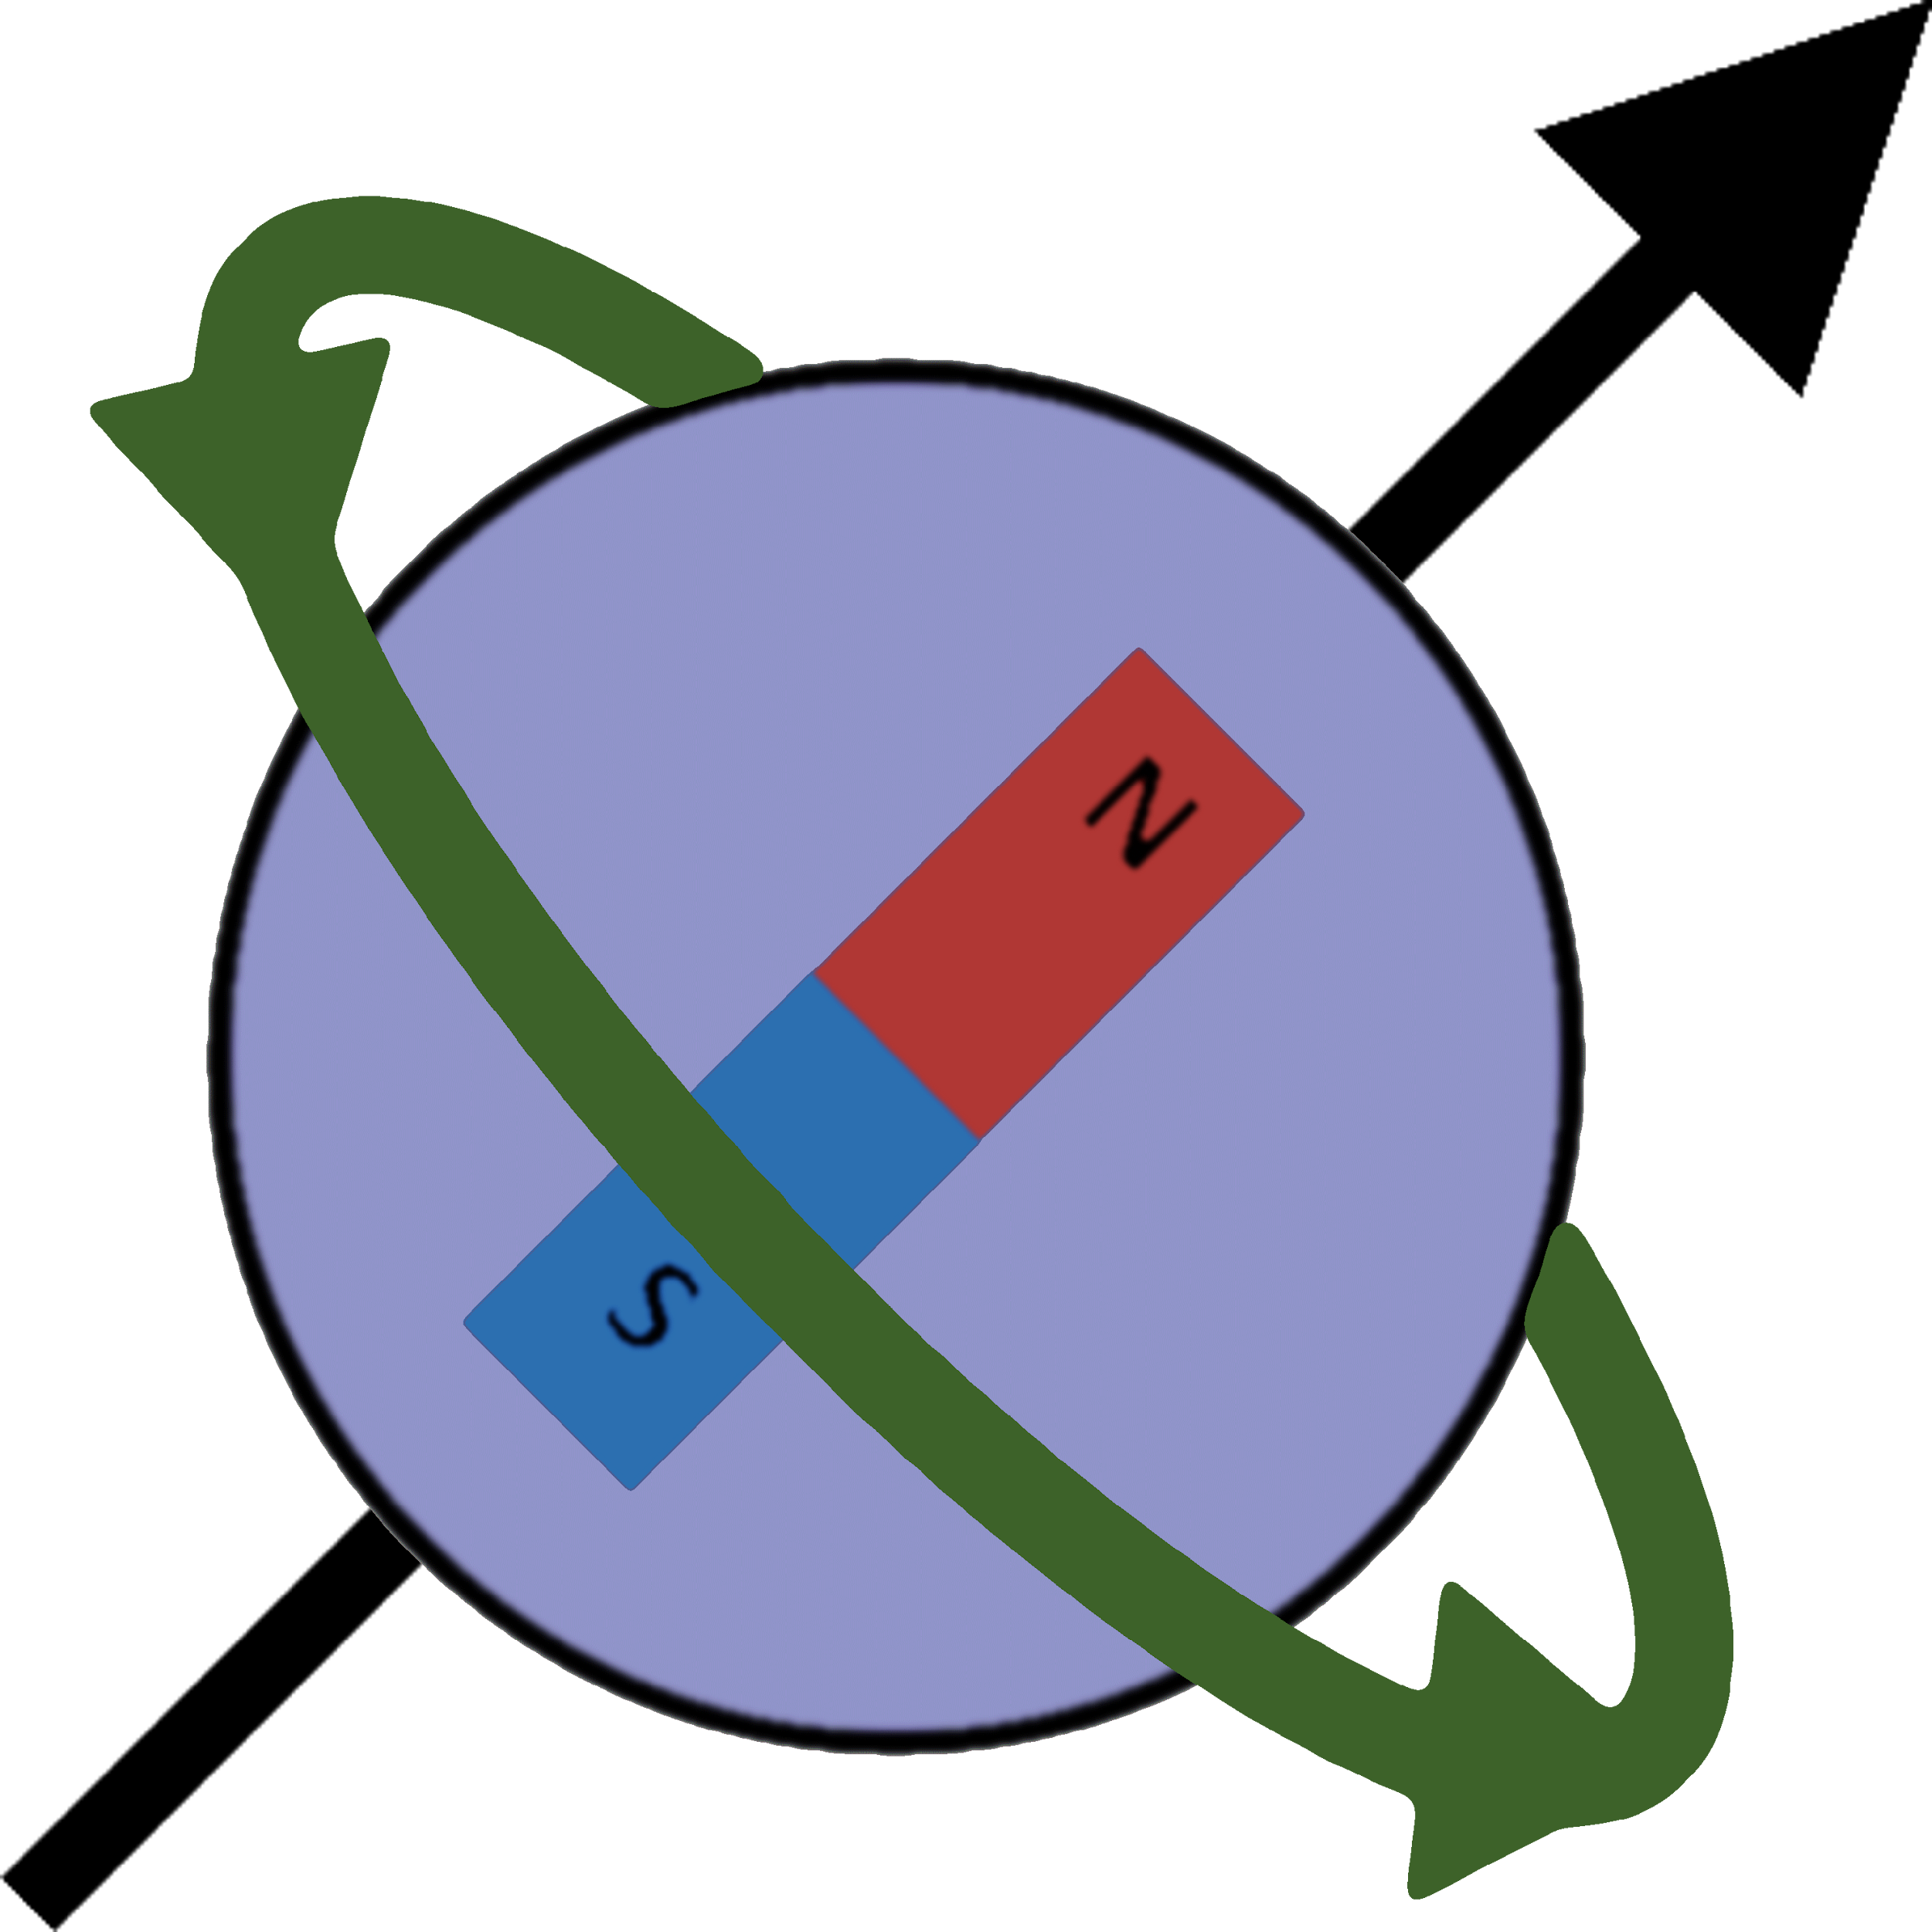

***Example Real-World Application*** Spintronics (also known as spin electronics) makes use of spin-dependent electron transport phenomena in solid-state devices to provide new electronic systems that can be more efficient for data storage and transfer (1).

## *Expected Learning Outcomes*

*At the end of this module, students should be able to…*

1. *describe what is observed without trying to explain, both in words and by means of a picture of the experimental setup (*[*Scientific Ability B5*](https://sites.google.com/site/scientificabilities/rubrics)*)*
2. *design a reliable experiment that tests the hypothesis (*[*Scientific Ability C2*](https://sites.google.com/site/scientificabilities/rubrics)*)*
3. *make a reasonable judgment about a given hypothesis based on experimental data (*[*Scientific Ability C8*](https://sites.google.com/site/scientificabilities/rubrics)*)*

**“We must be clear that when it comes to atoms, language can be used only as in poetry.”**

— Niels Bohr

# Background Information

**quantum spin** - a property of quantum particles that has many mathematical similarities to macroscopic spinning objects but also has unique quantum properties not observed in the macroscopic realm

**elementary particles** - subatomic particles that make up all known matter and cannot be divided any further into constituent parts

The **quantum spin** of a particle is one of the few physical properties that uniquely identify an **elementary particle** (along with information like mass and electric charge). We have seen that quantum spin is quantized and allows atoms and subatomic particles to interact with an external magnetic field. In this module, we’ll explore in more depth the behavior of quantum spins in a magnetic field in order to build up a classical analog of quantum spin that will be useful in making sense of the physics behind magnetic resonance in later modules.

For the activities below, we will be making use of the [magnetic torque apparatus](https://www.teachspin.com/magnetic-torque) that provides a physical model of a quantum spin that has been designed to have many of the same dynamical behaviors as real quantum spins, despite being a very classical, macroscopic object. Using this apparatus, we will explore important physical aspects of quantum spin and its behavior in an external magnetic field.

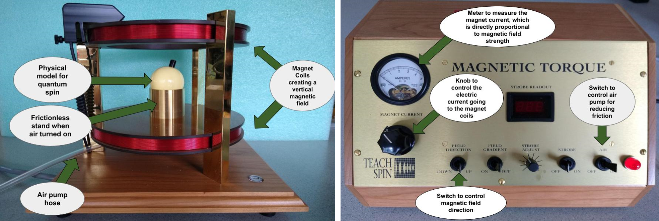

**Check out the** [**SLC Physics YouTube Channel**](https://www.youtube.com/channel/UCXiqWo-GgU5ULgQTwQ5wLyw/null) **for videos related to this module**

<https://www.youtube.com/channel/UCXiqWo-GgU5ULgQTwQ5wLyw>

# Observation Experiment - What does spin got to do with it?

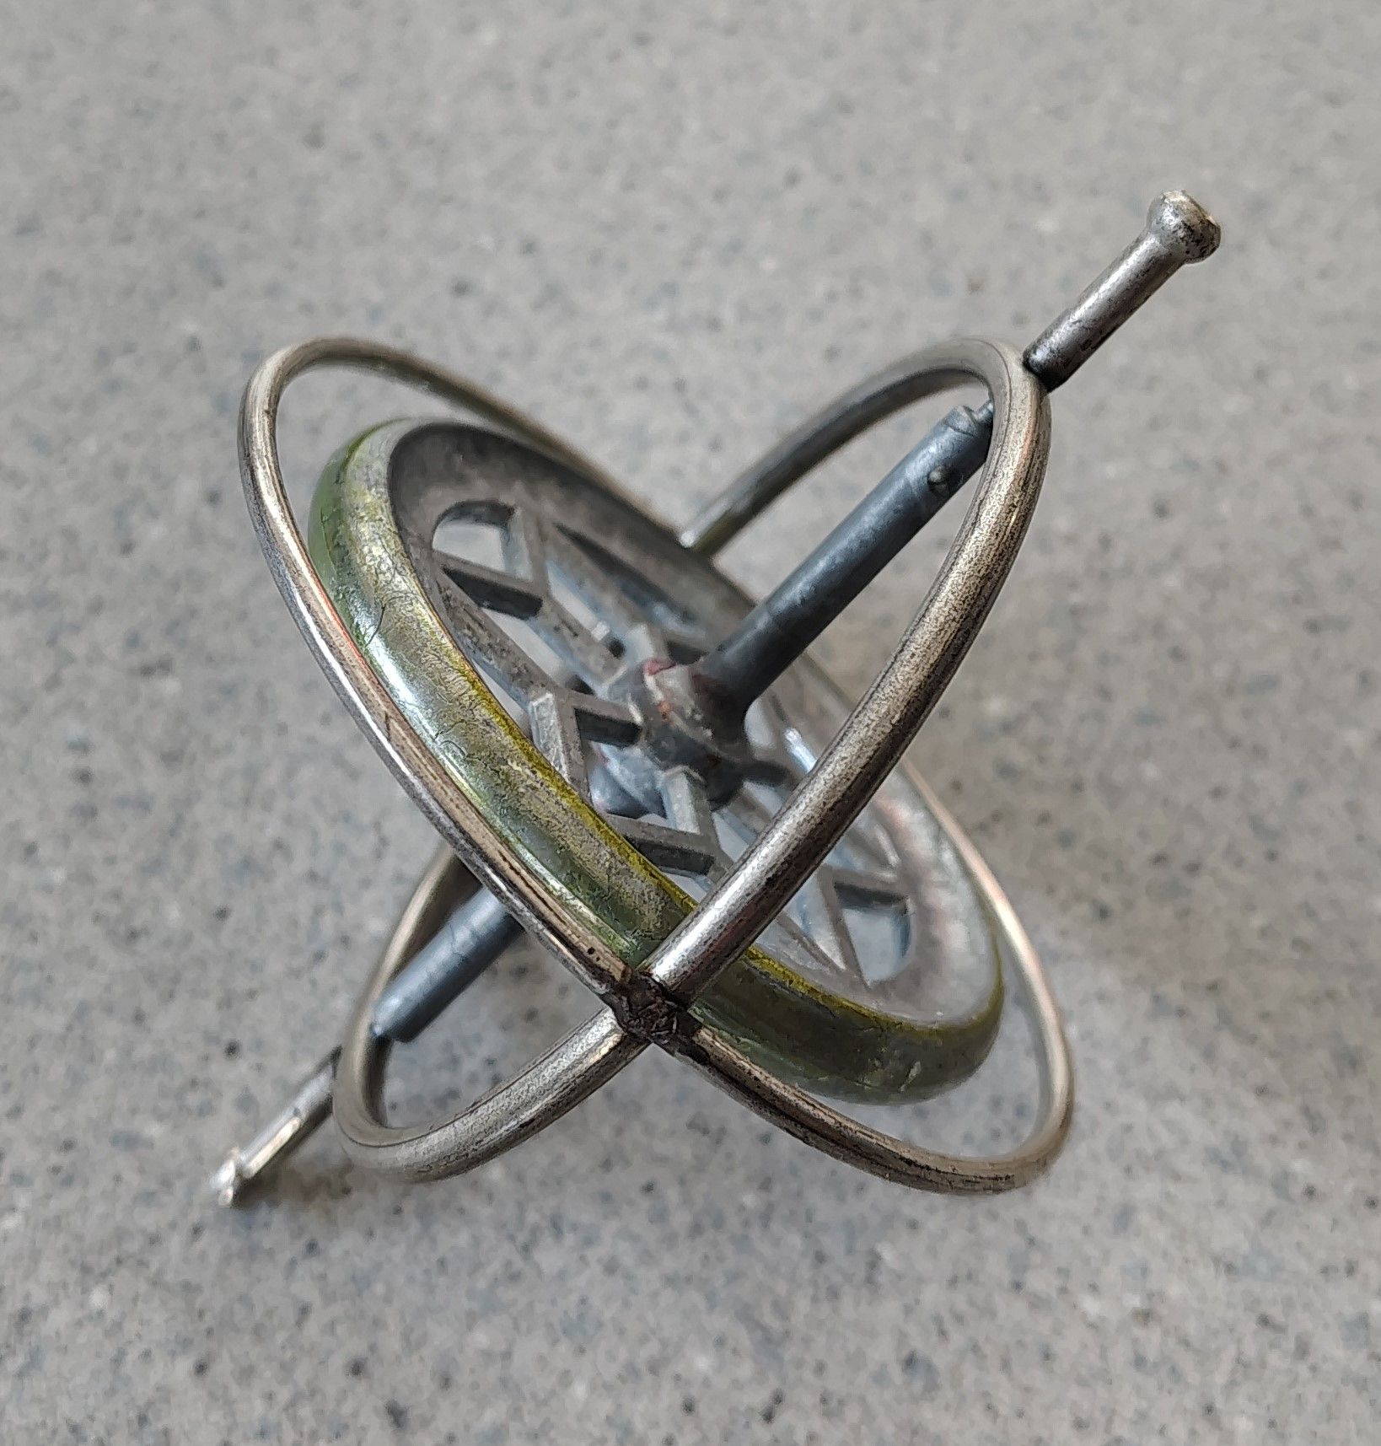

Classic gyroscope toy, photo courtesy of Merideth Frey.

Let’s observe the behavior of a gyroscope (essentially a fancy version of a toy top) that is first set on its point *without* spinning and then started off on its point *with* spinning. We want to write down everything we observe in both cases and try not to write comments or explanations for what is observed. We are going to develop our model of spin from the ground up, and try our best not to introduce any prior knowledge or assumptions that do not come directly from our observations.

## Class-Wide Discussion

* What do we observe when the gyroscope is set on its point without spinning?
* What do we observe when the gyroscope is set on its point with spinning?
* Observe the behavior of our physical model of quantum spin in the video found at the following link: <https://youtu.be/gefEQFjcmQE>. Does it behave more like a spinning object or non-spinning object?

# The Spinning Aspects of Quantum Spin

**angular momentum, $\vec{L}$**  - a physical vector quantity related to how much stuff is spinning about some axis of rotation and how fast it is spinning

The name ‘spin’ comes about due to some of the mathematical similarities of quantum spin behavior and macroscopic spinning objects. Most notably both types of ‘spin’ seem to have some form of **angular momentum**. In fact, quantum spin is often referred to as ‘intrinsic angular momentum’.

## Angular Momentum

**vector** - a mathematical quantity that has both a magnitude and direction and is usually visualized using an arrow; vector quantities will be denoted with little arrows on top, like $\vec{A}$

**axis of rotation** - a straight line through all points in a rotating object that remain stationary; often where the axle of a rotating object is placed (e.g. through the center of a bike wheel)

In classical physics, angular momentum is a **vector** typically denoted by $\vec{L}$ and represented by an arrow that points along the **axis of rotation**. The direction the angular momentum arrow points is determined by whether the object is rotating clockwise or counterclockwise and can be found by using the **right-hand rule**, shown in the figure below.

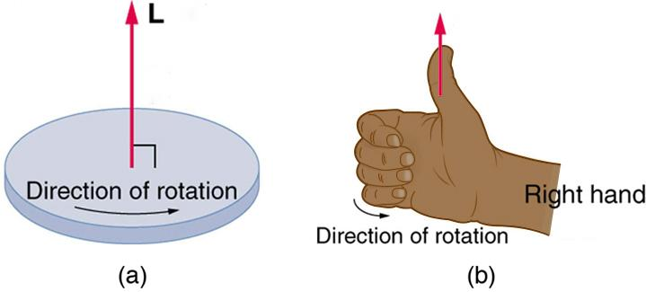

**right-hand rule** - make a thumbs up with your right hand and rotate your hand so that your fingers curl in the direction of rotation of the spinning object (e.g. as if the tips of your fingers were the head of the rotation arrow); your thumb now points in the direction of the angular momentum $\vec{L}$.

Adapted image by removing extra equations and variables from source: OpenStax College Physics 2e, [CC BY-NC-SA 4.0](https://creativecommons.org/licenses/by-sa/4) (2)

## Spin Angular Momentum

Commonly denoted by $\vec{S}$, which is a **vector** that has the same dimensions as angular momentum, but typically will be written in terms of $ℏ=h/2π$ where h is Planck’s constant *(If you see an $h$ or $ℏ$ anywhere, it is a sure sign you are dealing with quantum behavior!)*

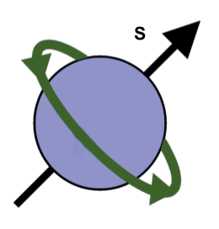

For a quantum spins, this angular momentum vector is replaced with the spin angular momentum vector, $\vec{S}$. As a helpful visualization of quantum spins, we will use a rotating sphere, and have an arrow depicting the direction of the spin angular momentum. It is important to point out that despite this helpful visualization, there is not a particle actually spinning at the quantum level. Unfortunately, there are no perfect classical models that encapsulate all the full weirdness of quantum particles!

## Guided Inquiry Questions

**FUN FACT!** Physicists understood early on that the electron could not be physically spinning. Simple classical calculations using the size and mass of the electron would suggest the outer 'surface' of the electron would need to move much faster than the speed of light to produce the angular momentum observed. But the quantum spin properties matched so well with angular momentum, that in lieu of better alternatives, physicists simply describe spin angular momentum as some form intrinsic angular momentum whose physical explanation is still a mystery. To learn more about the fascinating history and current theories of physicists trying to unlock the mysteries of the spinning aspects of quantum spin, see ["Quantum Particle Aren't Spinning. So Where Does Their Spin Come From?"](https://www.scientificamerican.com/article/quantum-particles-arent-spinning-so-where-does-their-spin-come-from/).).

1. Many people use ‘spin’ to refer to either the spin quantum number or the spin angular momentum vector. If I were to tell you the spin of a particular electron is $ℏ/2$, which aspect of spin am I talking about?
2. Draw a picture of a spin rotating in the opposite direction to the one shown above. *Make sure to draw the $\vec{S}$ vector pointing in the correct direction using the right-hand rule!*
3. Based on the behavior observed of our physical model of a quantum spin, do you think it is safe to say that it has some angular momentum and that angular momentum is an important factor to explaining the dynamical behavior observed?

# Testing Experiment - What causes the quantum spin to interact with magnetic field?

We have seen that a key aspect of quantum spin is that it interacts with an external magnetic field. In this activity, we want to explore if we need to add anything in addition to angular momentum to our classical analog of quantum spin to explain why our physical model of a quantum spin (the white cue ball) behaves the way it does in a magnetic field.

**Observation Experiment** Compare how the physical model of quantum spin (white cue ball) and a gyroscope behaves in the presence of a magnetic field *without* spinning either the cue ball or the gyroscope. Check out this video at the following link: <https://www.youtube.com/watch?v=oeGGhglvBiI> for behavior of the white cue ball with and without a magnetic field applied.

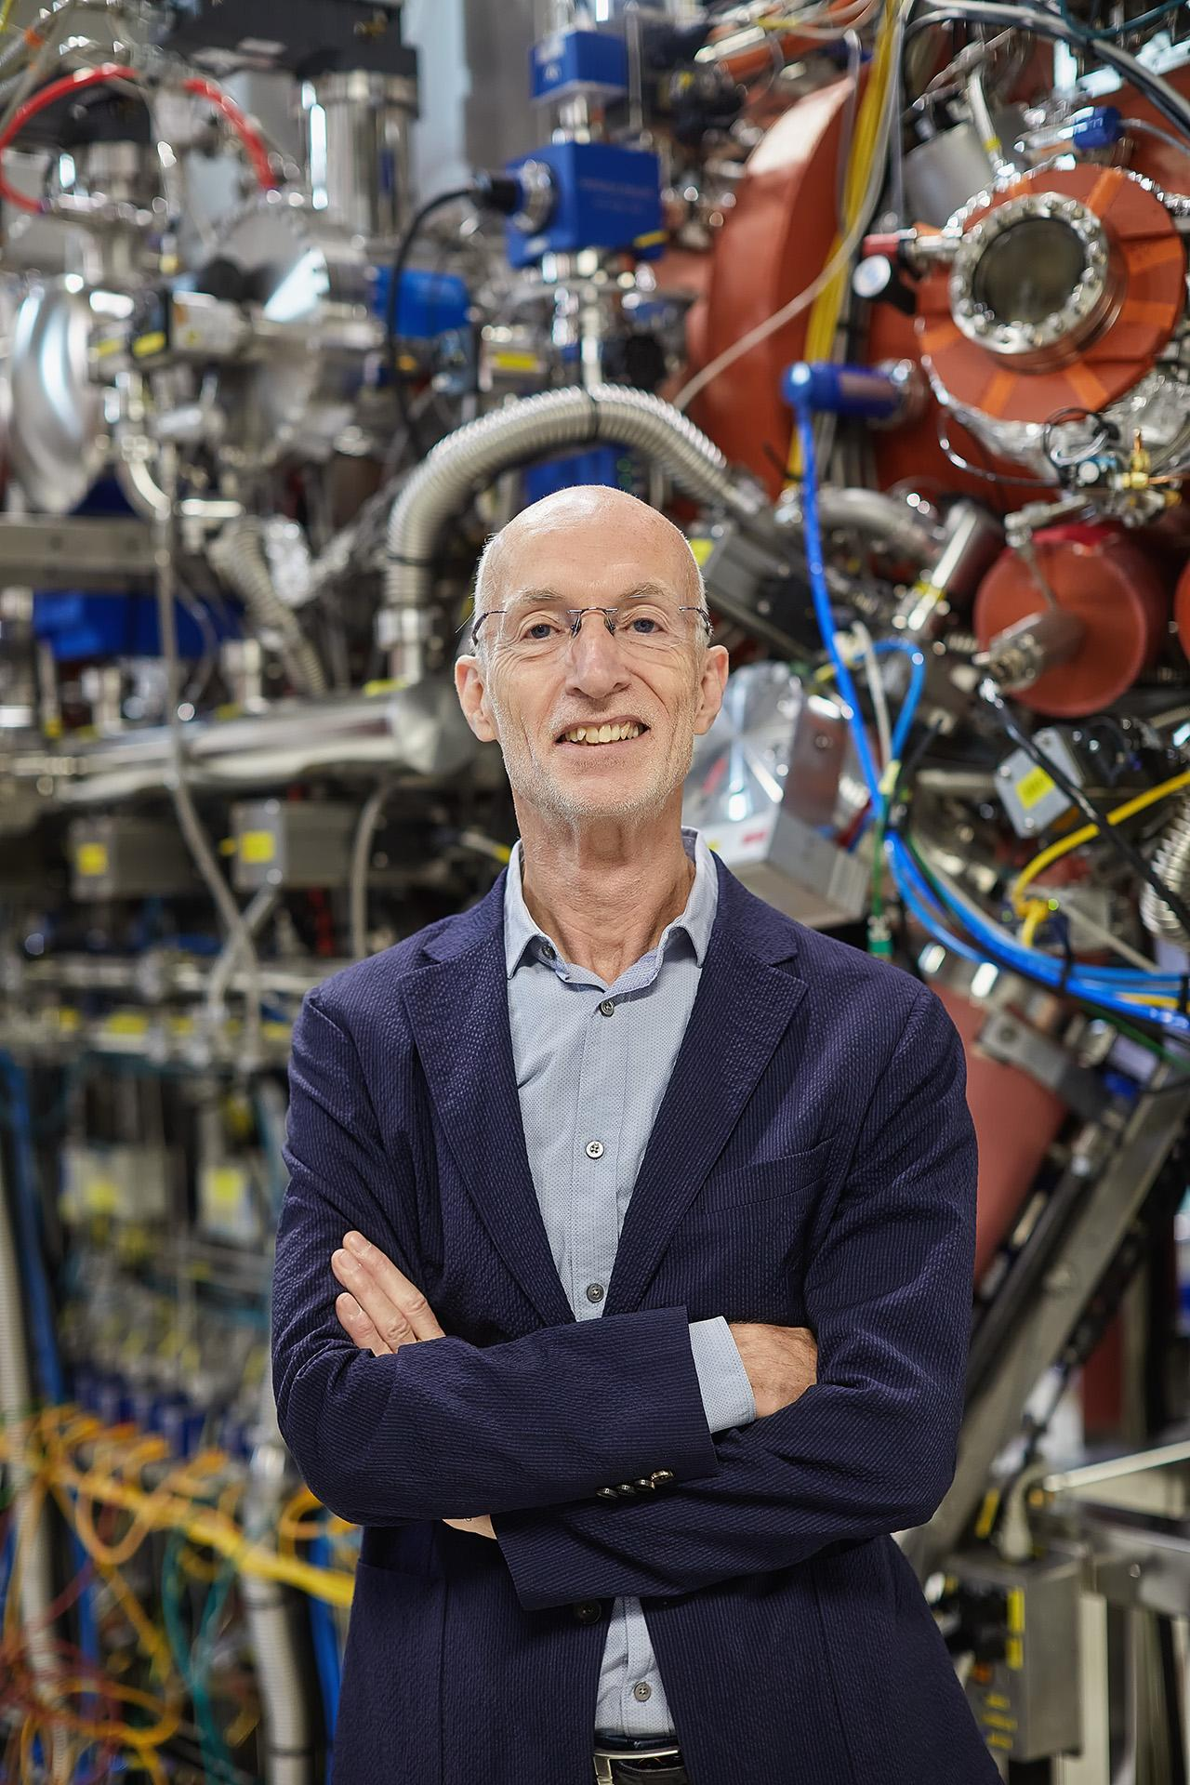

Photo by MPI für Mikrostrukturphysik / Marco Warmuth - Own work, [CC BY-SA 4.0](https://creativecommons.org/licenses/by-sa/4) (3)

***Featured Physicist*** Stuart Parkin is currently the Director at Max Planck Institute for Microstructure Physics and his research has focused on applied spintronics, particularly applying the giant magneto-resistance effect to enable a thousandfold increase in the storage capacity of magnetic disk drives. You can learn more about his work here: <https://www.mpi-halle.mpg.de/nise/director>.

## 

## Guided Inquiry Questions

1. Describe (using both words and pictures) what you observe of the behavior of both the white cue ball and gyroscope in the presence of a magnetic field without any spinning.
2. List some different explanations for why our physical model of a quantum spin (white cue ball) can interact with a magnetic field. *Some explanations may seem more plausible than others, but list all the explanations you can think of, since we don’t know what the correct answer may turn out to be, and it may not be the most obvious one!*
3. For your list of explanations (this will become your different *hypotheses*), design an experiment whose outcome you can predict using all the hypotheses that you constructed. *Note that when there are multiple explanations, the best designed experiment will give different predicted outcomes, allowing us to determine which explanation best explains the observed phenomenon*.
4. For each different hypothesis: write down what you would predict to observe if you performed your chosen experiment and that particular hypothesis were correct. For example, “If [hypothesis] is correct and we perform [experiment], then we would predict [predicted outcome for that hypothesis].”
5. If you ultimately observed something different than your prediction for a particular hypothesis, what would that tell you about that hypothesis?
6. Perform your experiment and/or watch some of the videos of the different experiments students have performed. Write down a brief description of the experiment being performed, and the observed results of that experiment. Based on the experimental results, what is your judgment about your different hypotheses?

[Experiment #1](https://www.youtube.com/watch?v=gC_V5dMGPAc)

[Experiment #2](https://www.youtube.com/watch?v=I-errBCWgEA)

1. Based on the experimental results, is there a particular hypothesis that provides the best explanation of why the white cue ball interacts with a magnetic field? Please explain by referencing the experimental results.

# 

# The Magnetic Aspects of Quantum Spin

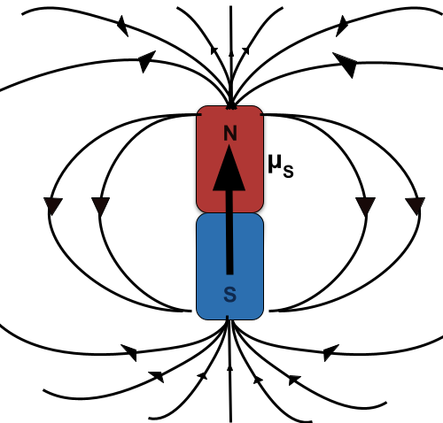

**magnetic moment, $\vec{μ}$** - also known as magnetic dipole moment or magnetic dipole; vector quantity that gives the magnetic strength and orientation of a magnet or other object that produces a magnetic field; we will visualize it as a bar magnet OR an arrow whose head would be the north pole and the tail would be the south pole.

**dipole** - two poles (e.g. the north and south pole of a magnet); often contrasted with monopole - one pole - (e.g. a positive electric charge would be considered an electric monopole)

Physical objects can also have magnetic properties, which is encapsulated in the **magnetic moment** of the object and denoted by $\vec{μ}$. This is sometimes also called a magnetic **dipole** moment or magnetic dipole. The magnetic dipole moment can be visualized as an arrow that points from the south pole to the north pole of a tiny, little bar magnet. Essentially, the arrow representing the magnetic moment is aligned with the magnetic field it produces. The convention is that the magnetic field lines point away from the north pole and loop back to point towards the south pole, as shown in the figure in the margin.

**FUN FACT!** No matter how you cut up a magnet, you always get two poles in the remaining pieces, and the intrinsic magnetic moment of fundamental particles is a magnetic dipole. Magnetic monopoles have never been found in nature, though scientists have searched for them because they would bring a nice symmetry to the laws of physics and have some pretty nifty physical properties. You can read more about magnetic monopoles [here](https://www.forbes.com/sites/startswithabang/2021/09/03/ask-ethan-what-impact-could-magnetic-monopoles-have-on-the-universe/?sh=2a523b236818).

## 

## Spin Magnetic Moment

**gyromagnetic ratio, $γ$** - a constant for a particular quantum spin that directly relates the spinning (*gyro*) aspects of quantum spin with the magnetic aspects

Elementary particles can also have magnetic moments, including an intrinsic magnetic moment caused by the particle’s spin. This is very cleverly called the spin magnetic moment of the particle and denoted by ${\vec{μ}}_{S}$. There is a very simple and direct relationship between the spin magnetic moment and the spin angular momentum $\vec{S}$ of the particle:

${\vec{μ}}_{S}=γ\vec{S}$

where $γ$ is a constant called the **gyromagnetic ratio** and has particular values for each type of particle. This simple expression shows that if you know the spin angular momentum and the gyromagnetic ratio of the particle, you can easily calculate its spin magnetic moment. But even more importantly for our purposes, this equation tells us that the spin magnetic moment is always aligned (pointing in the same direction) or anti-aligned (pointing in exactly the opposite direction) with the spin angular momentum, depending on the sign of the gyromagnetic ratio.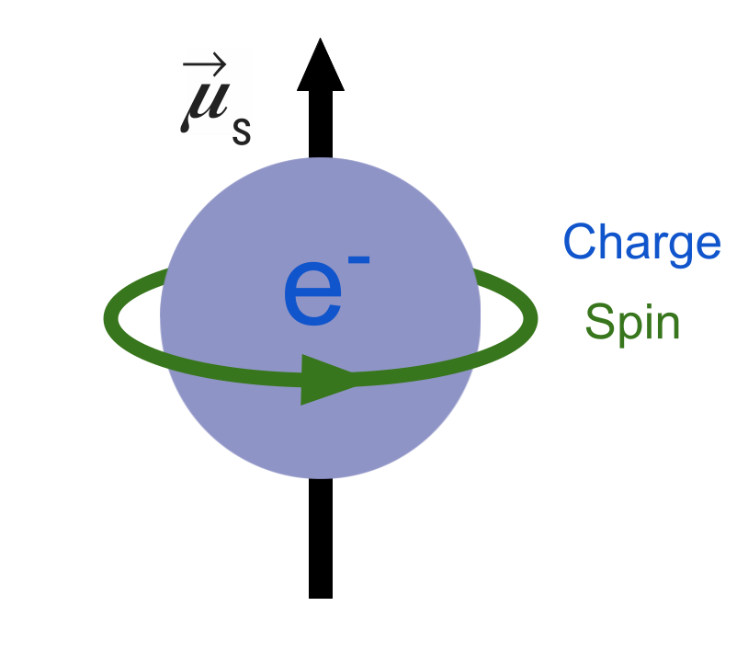

Classical model of a spinning electron. The spinning negative charge generates a magnetic moment that points along the axis of rotation. This model helps explain why the spin magnetic moment, ${\vec{μ}}_{S}$, of charged particles like the electron and proton align or anti-align with the spin angular momentum vector, $\vec{S}$.

To motivate the connection between the magnetic moment and angular momentum aspects of spin, it may be helpful to imagine a quantum spin (such as the electron shown to the right) as a spinning spherical shell of electric charge. This spinning shell of charge effectively forms a current loop that creates a magnetic moment pointing along the axis of rotation (i.e. aligned or anti-aligned with the angular momentum vector, depending on whether it is a positive or negative charge). In fact, using this reasoning, one can predict that the electrically neutral neutron **must** be made up of electrically charged components since it has a non-zero spin - and this turns out to be a correct prediction since we now know that the neutron is made up of three electrically-charged quarks. Despite its usefulness, we also know that this classical picture cannot actually be correct. Given the measured upper limits on the diameter of the electron, the electron’s surface would need to be moving faster than the speed of light in order to match the observed magnetic moment. (For more information, check out the ***FUN FACT!*** in the *Spin Angular Momentum* section.)

Thus we can complete our full visualization of a quantum spin which contains both the spin magnetic moment and the spin angular momentum.

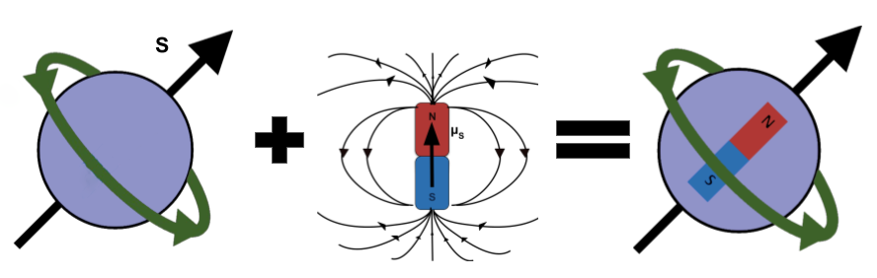

## Guided Inquiry Questions

1. In the visualization of a quantum spin given above with both the spin magnetic moment (as a bar magnet) and the spin angular momentum, is the gyromagnetic ratio positive or negative? How can you tell?
2. Draw your own visualization of a quantum spin with a negative gyromagnetic ratio. *Feel free to have it rotate in any direction, but make sure to draw the $\vec{S}$ vector pointing in the correct direction using the right-hand rule!*

# Exploratory Experiment - What determines the frequency of precession of a quantum spin?

You may have noticed that both a gyroscope and our physical model of a spin will have some interesting motion when the axis of rotation is not perfectly aligned with the vertical direction. Instead of the axis of rotation remaining stationary, it will slowly start moving around in a horizontal circle. This behavior is called **precession**.

**precession** - the circular motion of the axis of rotation of a spinning body around another axis

**torque, $τ$** - the rotational force that causes a change in angular momentum, just as a linear force causes a change in linear momentum

In a gyroscope or spinning top (as illustrated below), precession is caused by the fact that the angular momentum of an object will change in the same direction as any **torque**, $\vec{τ}$, applied to the object. The torque direction can be found in this case by doing a cross product of the displacement vector of the center of mass relative to the pivot point, $\vec{r}$, and the force of gravity on the object, $M\vec{g}$. The resulting cross-product of two vectors is always perpendicular to both vectors. Since $\vec{L}$ is parallel to $\vec{r}$, the resulting torque, $\vec{τ}$, is always perpendicular to the angular momentum vector, $\vec{L}$. This causes the angular momentum vector to precess by moving in a circle as shown. *Note: If the angular momentum were zero (i.e. the top were not spinning), then the torque caused by gravity would simply cause the top to tip over, as you would expect.* Vector cross products can be a common source of confusion for students, so no worries if you do not understand it completely. The main point is that the physics behind this behavior is well understood, despite the seemingly surprising motion that occurs.

The physics behind a precessing top. The torque is caused by gravity acting on the center of mass that is displaced from the pivot point. Image Source: OpenStax University Physics, [CC BY-NC-SA 4.0](https://creativecommons.org/licenses/by-sa/4) (4)

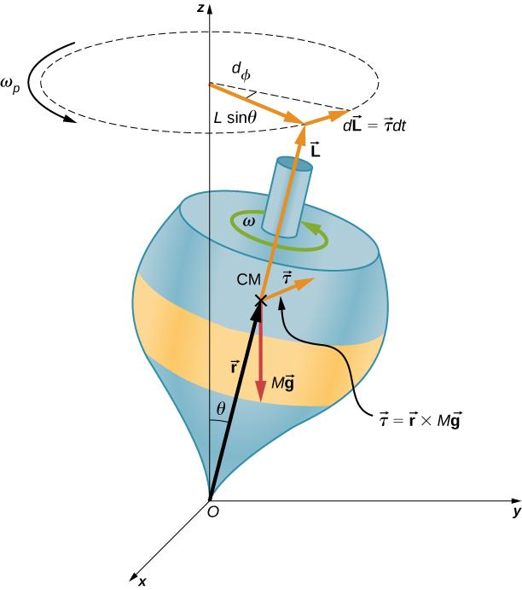

The **precession frequency** can provide us with useful information about the spinning system, whether it is a gyroscope or a quantum spin. In this section, we aim to explore what *causes* precession in our physical model of quantum spin and what parameters effects the resulting precession frequency.

**precession frequency** - how many cycles the object precesses per second; often this is easier to calculate by determining the time for the object to complete one complete circle (this time is called the period, T) and then the frequency would be 1/T.

## Guided Inquiry Questions

1. Consider the different possible ways we can set up precessional motion of our physical model of a quantum spin (the white cue ball), including the different apparatus controls highlighted in the diagram given in the **Background Information** section. List all the possible variables you can think of that might influence the precession frequency of our physical model of a quantum spin.
2. Perform some experiments and/or watch some of the videos of the different experiments students have performed. *Try to only change one variable at a time! If a particular variable is hard to reliably reproduce, then test that particular variable first so you can better understand its influence on future experiments.* For each experiment, write down what independent variable was being changed, your observations of the impacts on the precession frequency, and your conclusion on whether that independent variable impacts the precession frequency or not.

[Experiment #1](https://www.youtube.com/watch?v=gT5YXv-pb0c)

[Experiment #2](https://www.youtube.com/watch?v=AwuQX8LxTtc)

[Experiment #3](https://www.youtube.com/watch?v=S1U6nmGQP3g)

[Experiment #4](https://www.youtube.com/watch?v=zdejRIiTKxs)

1. Based on the experiments above, what variable/s influence the precession frequency of our physical model of a quantum spin?

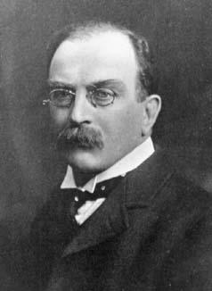

Author Unknown, Public domain, via Wikimedia Commons (5)

**Sir Joseph Larmor** - Among his many contributions to theoretical physics, Larmor created the first solar system model of the atom in 1897, postulated the proton (calling it a “positive electron”), and explained the splitting of the spectral lines in a magnetic field by the oscillation of electrons given rise to the Larmor precession frequency.

# 

# Larmor Precession

The precession of a quantum spin has some simularities to the precession of a gyroscope. The spin angular momentum vector, $\vec{S}$, precesses because there is a torque applied on the spin. However, instead of the torque being caused by the gravitational field (as it is for a top or gyroscope), the torque is caused by the magnetic moment of the quantum spin interacting with the *magnetic field*, $\vec{B}$. More specifically, the torque is the cross product of the spin magnetic moment, ${\vec{μ}}_{s}$, and the magnetic field, $\vec{B}$. Since ${\vec{μ}}_{s}$ is always either parallel or anti-parallel to $\vec{S}$, the applied torque will always be perpendicular to $\vec{S}$, and thus cause precession of the quantum spin. Check out the figure below for a comparison of the precession of a top and a quantum spin.

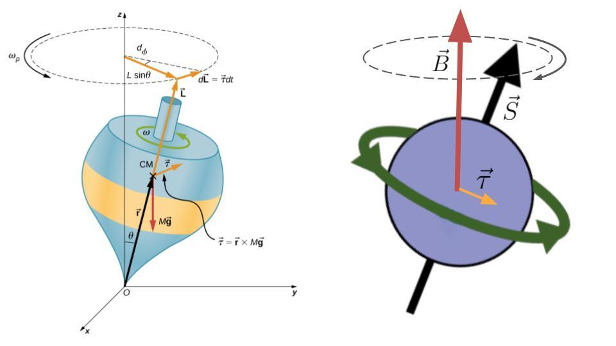

The physics behind a precessing top and a precessing quantum spin. *Note: The magnetic field, $\vec{B}$, is taking over the role of M $\vec{g}$.* For the quantum spin, the torque is caused by the interaction of the spin magnetic moment with the magnetic field.

The precession of a quantum spin is called *Larmor precession* and the precession frequency is simply dictated by only a few parameters: the gyromagnetic ratio of the spin, $γ$, and the strength of the magnetic field, $B$. The frequency of Larmor precession $f$ is given by:

$f=γB,$

when the gyromagnetic ratio given is in units of frequency (typically megahertz, MHz) divided by magnetic field strength (typically Tesla, T). Each quantum spin has a unique gyromagnetic ratio, $γ$, and thus a unique precession frequency when placed in the same strength magnetic field. **This turns out to be the most important and useful equation in all of magnetic resonance. Burn it into your memory and appreciate its simplicity!**

*Check out the table below for the gyromagnetic ratios for different nuclei and particles.*

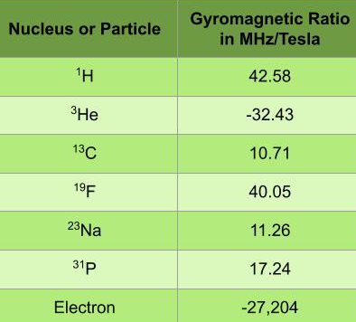

**FUN FACT!** Measuring the precession frequency of quantum spins in a magnetic field is one of the most precise measurements that scientists can make. Check out [https://physics.aps.org/articles/v16/22](https://physics.aps.org/articles/v16/22%20) to learn how precise measurement of the electron`s magnetic moment can help test the standard model of physics. Check out <https://physics.aps.org/articles/v16/80> to see how the measurement of the precession frequency of two isotopes of xenon can help probe into the regime where quantum theory meets gravity.

## Guided Inquiry Questions

1. In the apparatus we have been using, the magnet current in the magnet coils are directly proportional to the magnetic field strength (e.g. if you took the current value and multiplied it by a particular constant, you would get the magnetic field strength, $B$.) If you doubled the magnet current, what would you expect to happen to the magnetic field strength? What would happen to the precession frequency?
2. Do your conclusions from your precession experiments above appear to agree with the Larmor precession frequency equation given for a quantum spin? Explain.
3. Are there any differences with the behavior of our physical model of a quantum spin and the theoretical quantum behavior given by the Larmor precession frequency equation? What does this suggest about the possible limitations of our physical model? *You can see how a real quantum spin behaves according to quantum mechanics using the* [*Bloch simulator*](https://www.drcmr.dk/BlochSimulator/)*, which we will be using in future modules!*
4. What precession frequency would you expect for $​^{1}$ H in a 2-T magnetic field? What precession frequency would you expect for an electron in the same magnetic field? What do you think the negative sign means?
5. If you observed a Larmor frequency of 80.1 MHz in a 2-T magnetic field, which nucleus are you likely observing?

# Reflection Questions

**Example data table from an experiment performed in the previous activity**

| Magnet Current (Amps) | Frequency (Hz) |
| --- | --- |
| 0.0 | 0.00 |
| 0.5 | 0.05 |
| 1.0 | 0.06 |
| 1.5 | 0.10 |
| 2.0 | 0.14 |
| 2.5 | 0.16 |
| 3.0 | 0.20 |
| 3.5 | 0.27 |

1. What is the independent variable (i.e. the variable the experimenter was controlling) in the data given? What is the dependent variable (i.e. the variable that was measured)?
2. What experiment was being performed?
3. Neatly plot the data, with the independent variable on the x axis and the dependent variable on the y axis.
4. What type of relationship do these variables appear to have with each other (e.g. completely independent from each other, linear dependence, or some other dependence)?
5. Does this data match what we expect given the equation for Larmor precession of a quantum spin? Why or why not?

## Supplemental Readings

## • Gyroscopic Effects: Vector Aspects of Angular Momentum:<https://phys.libretexts.org/Bookshelves/Conceptual_Physics/Introduction_to_Physics_(Park)/03%3A_Unit_2-_Mechanics_II_-_Energy_and_Momentum_Oscillations_and_Waves_Rotation_and_Fluids/06%3A_Rotation/6.06%3A_Gyroscopic_Effects-_Vector_Aspects_of_Angular_Momentum>

## • Magnetic Moments and Dipoles:<https://mriquestions.com/magnetic-dipole-moment.html>

## • More Experiments with Magnetic Torque Apparatus:<https://www.teachspin.com/magnetic-torque>

## 

## Cited Sources

1. <https://en.wikipedia.org/wiki/Spintronics> “Wikipedia - Spintronics”
2. <https://openstax.org/books/college-physics-2e/pages/10-7-gyroscopic-effects-vector-aspects-of-angular-momentum> “Gyroscopic Effects: Vector Aspects of Angular Momentum”
3. <https://commons.wikimedia.org/w/index.php?curid=139363817> “Stuart Parkin - Wikimedia Commons”
4. <https://courses.lumenlearning.com/suny-osuniversityphysics/chapter/11-3-precession-of-a-gyroscope/> “Precession of a Gyroscope”
5. <https://commons.wikimedia.org/wiki/File:Joseph_Larmor.jpeg> “Joseph Larmor”